Transcatheter Aortic Valve Implantation in-patient referral proforma
Please return form to tavicoordinator@lhch.nhs.uk and TAVINurseSpecialists@lhch.nhs.uk

For Referring Organisation
Referring organisation name: | Referring organisation code:
Referring clinician: | Referring clinician registration code:
Contact name:
Contact phone:
Contact Email:

Patient details
Patient‟s surname: |  | Patient’s forename:
Title: |  | Date of Birth:
NHS number: |  | Local patient identifier:
Patient correspondence address:  Post code: |  | Contact details:  Name of lead contact if not the patient:  Mobile no: Day time no: Evening no:
GP details
GP name: |  | Practice code:
Receiving organisation details
Receiving organisation name:
LHCH
Receiving specialty department: Cardiology

TAVI Team
Date and time sent: | Date and time received:

Minimal data set Essential Information Required for the Referral to be accepted *

Clinical correspondence to include:  - Symptoms  - Comorbidities  - Frailty score (Rockwood frailty score prior to admission - please see below)  - Resuscitation status  - Current medications  IV diuretics or inotropes | - Yes | - No
Recent blood tests (FBC, U&E) | - Yes | - No
12 lead ECG | - Yes | - No
Echocardiogram report (please uploaded images) | - Yes | - No
Has a TAVI planning CT been performed?  (If so please uploaded images and report) | - Yes | - No

*Referrals that do not include details of symptoms, and functional status will be returned and may therefore cause delay to patient assessment

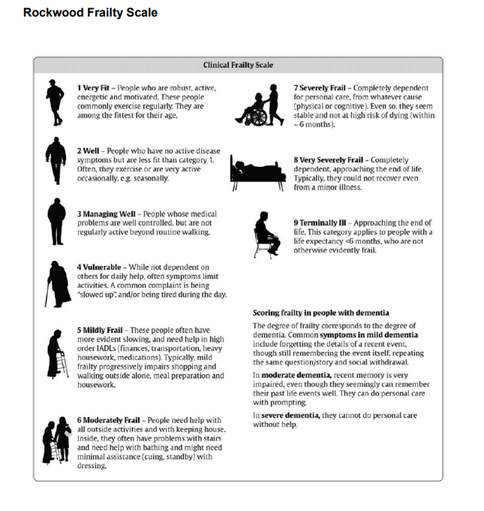
Clinical frailty scale. Moorhouse P, Rockwood K. Frailty and its quantitative clinical evaluation R Coll Physicians Edinb. 2012;42:333-340

