Ms Lucy Lavan
Liverpool Heart and Chest Hospital NHS Foundation Trust
Thomas Drive
Liverpool
L14 3PE

29th July 2011

Dear Ms Lavan,

LIVERPOOL HEART AND CHEST HOSPITAL NHS FOUNDATION TRUST
ELECTION TO THE COUNCIL OF GOVERNORS 2011

My report of voting in the above election, which closed at 5pm on Thursday 28th July 2011, is as follows.

Public: Merseyside

Number of eligible voters: |  | 4,583
Total number of votes cast: |  | 1,674
Turnout: |  | 36.5%
Number of votes found to be invalid: |  | 7
Blank or Spoilt  No declaration form received | 7  0
Total number of valid votes to be counted: |  | 1,667

Result (three to elect)

MAWSON, Debbie 1,071 Elected
PATTULLO, Paula Elaine 1,150 Elected
ROBERTS, Brian Peter 833
STOTT, Roy T 1,054 Elected

Public: North Wales

Number of eligible voters: |  | 1,690
Total number of votes cast: |  | 721
Turnout: |  | 42.7%
Number of votes found to be invalid: |  | 7
Blank or Spoilt  No declaration form received | 7  0
Total number of valid votes to be counted: |  | 714

Result (one to elect)

BENNETT, Denis F 144
BOWYER, Michael 228
JACKSON, Caroline 342 Elected

Staff: Qualified and Un-Qualified Nurses

Number of eligible voters: |  | 517
Total number of votes cast: |  | 116
Turnout: |  | 22.4%
Number of votes found to be invalid: |  | 0
Blank or Spoilt  No declaration form received | 0  0
Total number of valid votes to be counted: |  | 116

Result (one to elect)

FOULKES, Dave 73 Elected
RUMSBY, Neville 43

Electoral Reform Services can confirm that, as far as reasonably practicable, every person whose name appeared on the electoral roll supplied to us for the purpose of the ballot:-
- was sent the details of the ballot and
- if they chose to participate in the ballot, had their vote fairly and accurately recorded

The elections were conducted in accordance with the rules and constitutional arrangements as set out previously by the Trust, and ERS is satisfied that these were in accordance with accepted good electoral practice.

All voting materials will be stored for twelve months.

Yours sincerely
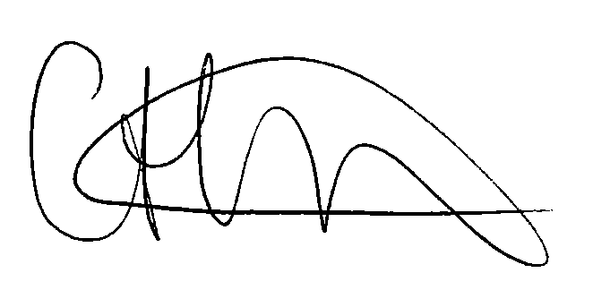

Caroline Hinchcliffe
Returning Officer
On behalf of Liverpool Heart and Chest Hospital NHS Foundation Trust

