

Mandatory Training Workbook 2015

Fire Safety

All Staff

Checklist
- Read through this section of the workbook.
- Complete the on-line assessment on My PACT
- If further information is required please contact the Fire Safety Officer on ext 1012

This section aims to explore your role in the event of a fire. It will cover basic fire safety, good housekeeping, actions to be taken on discovering a fire, actions to be taken on hearing a fire alarm, procedures for evacuation and staff responsibilities during a fire incident

Responsibilities for Fire Safety

You should work your way through the whole of the section and then complete the on-line assessment. By completing the assessment the trust will record that you have completed your statutory training in Fire Safety for this year. It is a legal requirement for the trust to provide you with this training and to ensure that you have the skills and knowledge to help you know what to do in the event of a fire. The Trust has a responsibility for ensuring fire safety is managed effectively in all premises it owns and where its staff are based. This includes everything from ensuring that the integrity of the building construction is appropriate to stop fire spreading quickly, through to ensuring staff are trained to respond if a fire occurs.

This course in only one part of your fire safety awareness training. You are responsible for ensuring that you undertake some training at a local level including identifying escape routes from your place of work, evacuation techniques, you should consult your line manager for more information on this. You may also be required to undertake more training at a local level and may be asked to demonstrate to a fire safety officer that you are competent in fire safety practices.

To contribute to our aim of providing a ‘safe’ environment, everyone has a responsibility for managing fire safety.

- Ward/Department/Unit Managers are responsible on a day to day basis for the implementation of fire safety arrangements in their areas of responsibility.
- Estates Department are responsible for the maintenance of ‘physical’ fire precautions measures in all buildings, for example, fire alarms and fire doors.
- Clinical Staff are responsible for ensuring the fire risks presented by patients are considered in their clinical risk assessment, and that appropriate control measures are implemented accordingly.
- All staff are responsible for reporting any fire safety problems, defects or concerns they may have, attending training and ensuring good fire safety housekeeping arrangements are maintained in their place of work.

Introduction

Thankfully, we don’t encounter fire every day, but if we are suddenly faced with it there will little time to then learn how to deal with it before it becomes too late. So, read this carefully in order to:

- Prevent a fire from starting in the first place.
- If a fire does occur, what to do IMMEDIATELY in order to protect yourself, your colleagues, your patients and your hospital

Understanding Risk and Hazard

A Hazard is anything that has the potential to cause harm
Risk has two elements; likelihood of occurrence, and severity.

Commonly in a risk assessment, all hazards are listed and then each is give a score taken from a matrix that quantifies its likelihood of occurrence, and the potential severity of damage.

The table below is an example of such a matrix.

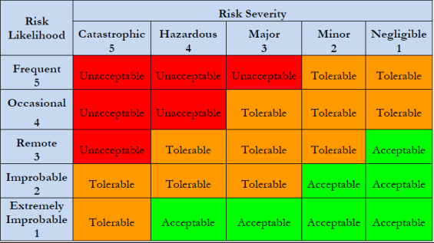
Take for example a few boxes of old files or a damaged chair left in an escape corridor for just a few days until you find somewhere to store them. In themselves they may appear harmless, but in case of a fire, where occupants are trying to escape, perhaps in the dark and perhaps with patients in beds, these obstacles could prove life threatening. It would be reasonable therefore to attribute a score of 4 ( hazardous) to the severity, and by referring to the above matrix, even occasional storage is unacceptable.
In a hospital, due to the potential to cause major harm to patients and staff, most hazards will be classed as 3 or above. It is for this reason that good housekeeping, safe practices and a vigilant, trained workforce is essential.

Understanding the Main Characteristics of Fire

In order for combustion to take place, the following three elements need to be present in sufficient quantities:

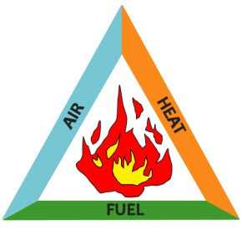

It follows that removing one or more of these elements will extinguish a fire.

Fuel

Clearly, not all materials will readily ignite or support combustion. Some will burn under normal conditions, for example paper cardboard etc, whereas other materials require specific conditions in order to burn e.g Aluminium will burn in pure oxygen.
It is not only the chemical composition of a material that dictates if it will easily burn or not, its physical form and its orientation are also important. An arsonist will have little success attempting to start a fire by holding a match under a copy of Yellow Pages, whereas the same match held under the bottom edge of a calendar or a poster on a noticeboard will quickly ignite and progress a fire - especially if the paper is only held on by pins at the top (the usual- cant find enough drawing pins so 2 will do)

Notices are to be kept to a minimum, posted only in designated areas and securely attached at all 4 corners

Air

Oxygen is required to support combustion and this is usually, but not always, provided by atmospheric air. Increasing the amount of oxygen will increase the temperature and the intensity of a fire. For example, a lit cigarette will flame when pure oxygen is passed over it –

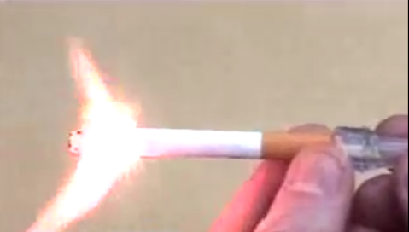

Increased oxygen supply is also achieved when a fire is well ventilated, consider blowing on smouldering tinder and the effect of wind on bush fires in hot, dry countries.

Shut off piped oxygen supply at isolators if there is a confirmed fire. Transfer patients to portable O₂ cylinders. Close all windows and doors when a fire has been confirmed.

Heat

Once a fire has started its heat is self sustaining because the heat from the flame vaporises more fuel which burns with a flame which in turn vaporises more fuel and so it goes.
However, energy is required in the form of heat in order to start the process and this usually comes from an external source. The most common of these in a hospital are:

- Smoking Materials Although this hospital adopts a no smoking policy, the reality is that some smokers are tenacious in their pursuit of nicotine and the practice remains a significant fire hazard. It is the careless discarding of unextinguished matches and cigarette buts that poses the risk, especially if they are tossed into a pile of dry waste paper, cardboard or plastics ( such as you might find in your average bin) and if there is a draught ( such as you might find outdoors- where smokers are required to be)

Strictly enforce the no smoking policy – challenge and report anyone found smoking on site

- Cooking Appliances This category includes all ovens, fat friers, microwave ovens, toasters and kettles. The main cause of cooking related fires is appliances being left unattended or used incorrectly. Toasters collect deposits of charred crumbs which continue to dry out and eventually ignite if repeatedly heated.

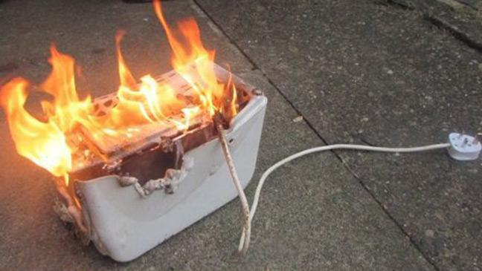

- Electricity and Electrical Appliances All electrical supply leads are rated to safely transmit currents up to a maximum. If, by running too many appliances from a multiplug adaptor, or by fitting an incorrect fuse, or by using a faulty piece of equipment, this maximum current is exceeded, the the cable insulation will heat up and become brittle. It will eventually no longer insulate the live from the neutral supply and the wires will arc. This is a very high temperature event and can easily start a fire.

A similar process can occur within a piece of electrical apparatus if it is faulty. This is why ALL portable appliances- toasters, radios, fans etc MUST be PAT tested before use and annually.

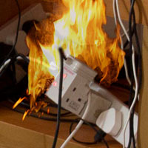
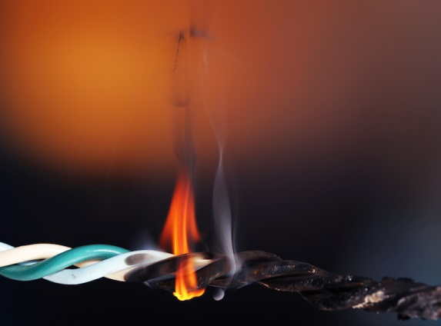

The Built Environment

Compartmentation

Fire safety is particularly important in hospitals because of the presence of patients, some of which are highly dependent and will require assistance to escape from fire. Because of this, hospitals are designed, built and maintained to provide a continuous series of protective compartments, each of which will withstand the passage of fire for up to one hour. This will give time for patients to be stabilised sufficiently to withstand further evacuation if needed. Thus evacuation is progressive and wherever possible it is horizontal in the first instance.

Fire Alarm

The fire alarm in the hospital has been designed and installed to facilitate this progressive evacuation such that only the area in which the fire is situated will sound a continuous evacuation signal. The areas immediately adjacent to this will receive an intermittent alarm.

Dept E

No alarm
Dept C

Intermittent alarm
Dept B

Continuousalarm
Dept A

Intermittent alarm

Dept G

Intermittent alarm
Dept F

Intermittent alarm
Dept E

Intermittent alarm

Non-clinical areas:

On hearing a continuous fire alarm:

- Leave the building quickly and calmly taking the safest and shortest route (preferably not through clinical areas). DO NOT STOP FOR PERSONAL BELONGINGS.
- Where possible, close all doors and windows
- Assemble at the appropriate assembly point and inform the person in charge, nominated Fire and Safety Officer, H&S officer, Fire or Police officer if you are aware of any person unaccounted for.
- Do NOT re-enter the building until told to do so by the person in control, e.g. Fire Officer or Health and Safety Officer.
- Fire Wardens to check location and nature of fire, inform switch via 2222 of findings even if this is a known false alarm.
- Fire Wardens tackle fire where safe to do so
- Fire Wardens, Office Managers, persons in charge of an area should ensure a speedy evacuation and all persons go to fire assembly point, taking with them the role board/ duty sheet/ attendance board

On discovering a fire:

- Operate the nearest manual call point
- Alert others in the area (shout FIRE)
- Dial …2222………….. on internal phone and inform switchboard of fire, giving as much information as possible:
    - Location, size & nature of the fire,
    - How many staff, visitors and if you are evacuating -where to.
    - The nearest location for attending fire appliances.
    - If this info is not known immediately, update Switch as soon as it is
- EVACUATE IMMEDIATELY
- Ensure role board/ duty sheet is taken with you
- Where possible, close all doors and windows
- Do not use the lifts
- Assemble at the appropriate assembly point and inform the person in charge, nominated Fire and Safety Officer, H&S Officer, Fire or Police Officer if you are aware of any person unaccounted for.
- Do NOT re-enter the building until told to do so by the person in control, e.g. Fire Officer or Health and Safety Officer

Clinical areas

On hearing a continuous fire alarm:

- Consult with Fire Warden/ Ward Manager/ Person in charge if evacuation is required
- If so, assist with patient evacuation immediately ( see below). DO NOT STOP FOR PERSONAL BELONGINGS.
- In the first instance, assemble at the first compartment with an intermittent alarm & carry out a role call
- Where possible, close all doors and windows when leaving
- Do NOT re-enter the ward/department until told to do so by the person in control, e.g. Fire Officer or Health and Safety Officer.
- Fire Wardens to check location and nature of fire, inform switch via 2222 of findings even if this is a known false alarm.
- Fire Wardens tackle where safe to do so
- Fire Wardens, Office Managers, all persons in charge of an area should ensure a speedy evacuation and all persons go to fire assembly point, taking with them the role board/ duty sheet/ attendance board

On discovering a fire:

- Operate the nearest manual call point
- Alert others in the area (shout FIRE)
- Dial …2222………….. on internal phone and inform switchboard of fire, giving as much information as possible:
    - Location, size & nature of the fire,
    - How many patients, staff, visitors and if you are evacuating -where to.
    - The nearest location for attending fire appliances.
    - If this info is not known immediately, update Switch as soon as it is
- If fire/ smoke is entering ward/ department -EVACUATE IMMEDIATELY (See below)
- Ensure role board/ duty sheet is taken with you
- Where possible, close all doors and windows
- Do not use the lifts
- Assemble at the appropriate assembly point and inform the person in charge, nominated Fire and Safety Officer, H&S Officer, Fire or Police Officer if you are aware of any person unaccounted for.
- Do NOT re-enter the building until told to do so by the person in control, e.g. Fire Officer or Health and Safety Officer

- Fire Wardens to check location and nature of fire, inform switch via 2222 of findings even if this is a known false alarm.
- Fire Wardens tackle where safe to do so
- Fire Wardens, Office Managers, all persons in charge of an area should ensure a speedy evacuation and all persons go to fire assembly point, taking with them the role board/ duty sheet/ attendance board
- Ensure medical oxygen is isolated at valves

Evacuation of clinical areas within Hospital Premises

- Evacuation of clinical areas within hospital premises is based upon the principle of progressive horizontal evacuation.
- Rather than evacuation immediately to the outside, patients, staff and visitors are moved along the same floor level, through the next fire compartment (through next set of doors), and progressively move in such a way until there is no choice but to then go downstairs and/or to the outside.
- This method of evacuation means that those who are ill, or for whom it would be less than favourable to evacuate immediately outside, are kept in a safe and protected environment until such time as the fire service arrive and can make the area they have been evacuated from safe or they are stable enough to be moved outside. ( only if the fire escalates to require full evacuation of hospital)

Patient evacuation

- Move patients nearest the fire FIRST
- Start with the most able first
- Take patients to the furthest point in the next compartment
- Close doors to affected area each time you pass through

Non clinical areas will normally evacuate to an assembly point outside the building. Know where yours is.

Good Fire Safety Housekeeping

Clearly, preventing a fire from happening in the first instance is far more desirable than dealing with the risk to life and to service delivery when one does occur . Steps that can be taken by all staff to reduce the risk of fire include:
- Store combustible materials away from potential ignition sources; paper, cardboard, aerosols etc
- Do not overload electrical extension cables by plugging adaptors into outputs
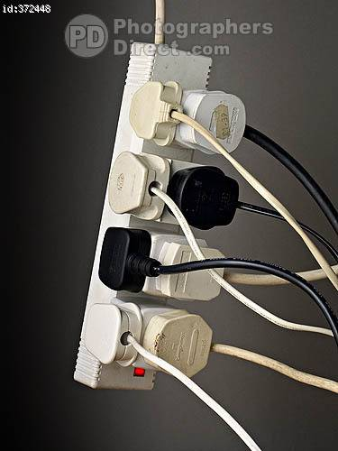

X

- Ensure electrical cables are not pulled or stretched
- Ensure only qualified electricians are employed to carry out any work involving repairs or modifications to electrical wiring
- Ensure all electrical equipment has been PAT tested (Portable appliance testing), this includes any personal equipment brought into the Hospital.

Remember:

Corridors and stairs should be kept free of all obstructions. Absolutely no storage except in marked designated areas.

Do not wedge fire doors open- ever.

If a set of doors is making life difficult by being closed then contact the Fire Officer on ext 1012 to seek a solution. Don’t be lazy and wedge them open, they are ESSENTIAL to keep you safe.

REPORT FIRE HAZARDS such as blocked fire escapes to your line manager immediately

Designated Fire Escape Routes

Wherever possible, two designed escape routes to a final exit door should be available throughout the hospital thus enabling those evacuating to escape away from a fire.

Designated fire escape routes are protected by fire doors and have directional signs located throughout their length to direct people to the final exit door. Fire alarm call points will be located adjacent to final exits. Emergency lighting will also usually be installed along these routes.

Fire Action

Staff training in fire safety is not only important but it is also a legal requirement so that everyone is aware of their responsibilities and the procedures they need to follow. It is for this reason that regular fire drills are performed. Whenever these drills take place, they may feel disruptive and not important at the time. It is worth pointing out that not only is cooperation with the requirements of the drill a legal obligation under The Regulatory Reform ( Fire Safety) Order 2005, but it is also required as part of your duties under The Health and Safety at Work Act 1974 ( section 7). It may also one day allow you to survive and help others survive a potentially life threatening situation

Arson

Sadly, arson is a major cause of NHS fires. Hospitals are usually open 24hrs a day every day and unfamiliar faces is commonplace. Arsonists don’t generally advertise themselves as such, and therefore being vigilant to any unusual or suspicious behaviour is essential. Inform
- Security immediately if you observe someone of acting in a suspicious manner.
- Do not make it easier for arsonists by allowing the accumulation of waste, combustible materials etc especially in common access areas.
- Keep your storage areas locked when not in use

Questions:

On discovering a fire, what should be your first action
- Inform your supervisor
- Evacuate immediately
- Extinguish the fire
- Operate the nearest manual call point

What action should you take if you accidentally set off the fire alarm?
- Evacuate immediately
- Carry on as normal
- Call switchboard and inform them it is a false alarm and wait for the fire team to arrive
- Blame someone else

Who is responsible for reporting any defects that may affect fire safety?
- The Fire Warden for the area
- The manager/ supervisor/team leader
- Everyone
- The local health and safety representative

What does an intermittent fire alarm mean?
- The fire alarm is faulty and someone will be out to fix it
- There is a fire in your department and you must evacuate immediately
- There is a fire drill taking place and ignore it
- There is a fire alarm actuation in an adjacent compartment and be ready to evacuate if instructed to do so

Whose responsibility is it to tackle a small fire in your department
- The Fire Brigade
- Your department supervisor
- Security staff
- The first trained or competent person if it is safe to do so

Once you have evacuated, what action should you now take?
- Go back to work and finish what you were doing in a safer place
- Stay together with all other evacuees and await further instructions from the responsible person
- Go home
- Watch from a safe distance

How do you know that you have evacuated out of your fire compartment?
- There is a sticker on the door informing you that you have passed to another compartment
- The compartment is painted in a different colour
- You don’t know
- The alarm changes from continuous to intermittent or silent

Whose responsibility is it to evacuate patients?
- The fire warden
- Any relative or visitor who is with them
- The ward/department manager
- Anyone and everyone who is able bodied enough to assist with the task

If a fire door is a hindrance to your daily work, what action should you take?
- Remove it
- Keep pushing it until it eventually sticks in place
- Use a wedge of non- combustible material under the door to hold it open
- Report it to the Fire Officer or Estates to seek a solution

Where are manual call points situated in the hospital
- All over the place
- Near the nurses station
- Adjacent to the fire alarm panel
- Adjacent to all final exit points and at intervals along corridors

On hearing the continuous fire alarm during a fire drill, what action should you take?
- Do nothing, ignore it and it will eventually stop and let you get on with your work
- Evacuate immediately regardless of which department you work in
- In none clinical areas evacuate without delay, in clinical areas ascertain if evacuation is necessary and then to assist accordingly
- Pretend you don’t know what it is until someone tells you that you must evacuate

When is it safe to return following an evacuation
- When your boss tells you its time to get back to work
- After 10 minutes if no one has told you otherwise
- When the continuous alarm stops sounding
- When a responsible person ( Trust Fire Officer. Brigade Firefighter, Policeman, member of Trust Fire Team) informs you it is safe to do so

