

Board of Directors (Public)
Item

Board report

Subject: LHCH Monthly Staffing for Reporting Period for November 2020
Date of meeting 26th January 2021
Prepared by: Fiona Altintas, Divisional Head of Nursing & Quality for Surgery
Julie Roy, Divisional Head of Nursing & Quality for Medicine
Kirsty Dudley, Critical Care Manager,

Presented by: Sue Pemberton, Executive Director of Nursing & Quality
Purpose of Report for Noting

BAF Ref | WC1, WC2, WC3, WC4
Impact on BAF | None

1. Executive Summary

The National Quality Board (NQB) publication Supporting NHS providers to deliver the right staff, with the right skills, in the right place at the right time: Safe, sustainable and productive staffing (2016) outlines the expectations and framework within which decisions on safe and sustainable staffing should be made to support the delivery of safe, effective, caring, responsive and well-led care on a sustainable basis. It builds on National Institute for Health and Care Excellence (NICE) guidelines on safe staffing for nursing in adult inpatient wards, and is informed by NICE’s comprehensive evidence reviews of research, and subsequent evidence reviews focusing specifically on staffing levels and outcomes, flexible staffing and shift work. The need to consider the wider multidisciplinary team when looking at the size and composition of staff for any setting is highlighted as important within these documents.

The nursing establishment is defined as the number of registered nurses, registered nursing associates, assistant practitioners and healthcare assistants who work in a particular ward, department or team. Decision-making to ensure safe and sustainable staffing must follow a clear and logical process that takes account of the wider multidisciplinary team. Although registered nurses, registered nurse associates and healthcare assistants (HCAs) provide a significant proportion of direct care, other groups to consider include:

- Medical staff
- AHPs
- Pharmacists
- Advanced clinical practitioners
- Volunteers

The Model Hospital dashboard makes it possible to compare with peers using care hours per patient day (CHPPD). Finding peers that are close comparators is important as aspects such as patient acuity, dependency, turnover and ward support staff will differ. While NICE guidance identified evidence of “increased risk of harm associated with a registered nurse caring for more than 8 patients during the day shifts”, it clearly states that there is “no single nursing staff-to-patient ratio that can be applied across all acute adult inpatient wards”. NHSI state that they have found no new evidence to inform a change to this statement (NHS Improvement Evidence Review One 2016). This report details planned and actual nurse staffing levels for the month of November 2020, including any red flag concerns. All shifts were reported as safe during this month.

In response to the Covid 19 pandemic recovery work, a review of the Trust’s bed base has been completed. The POCCU 3 10 bedded area remains available for Covid positive patients and is staffed flexibly by the critical care team. This area has remained open caring for covid positive ward level patients and critical care level patients during November. Oak ward reverted to a post-operative ward during November. Cedar ward has now been divided into 2 distinct zones with 10 beds for pre-operative patients following a green pathway and with 28 beds remaining for post-operative cardiac and thoracic patients.

Rowan Suite re-opened following structural works and was utilised for pre-operative patients initially until further capacity was required for covid positive patients within the Trust and its use was then altered for this purpose. Maple Suite has been utilised flexibly for both surgical and medical patients requiring side rooms. All CF patients continue to be safely cared for within Cherry ward (with its negative pressure rooms).

The Trust continues to carry a number of RN vacancies and during November, recruitment efforts have continued. A virtual open event is planned for early December, led by the senior nursing team along with education and HR colleagues. Temporary staffing arrangements are under constant review although unfortunately options to utilise NHS Professionals for interim temporary support have not proven successful to date.
A pan-Mersey approach to overseas RN recruitment is being progressed and led across the local trusts by LHCH’s Deputy Director of Education.

The new Trust HCA apprenticeship programme successfully launched in November, along with the Trust’s first cohort of health and social care cadets. These roles are key to ensure support of junior staff development and offer career progression within the Trust. All HCA vacancies have now been recruited into across the Trust, however sickness and other absence has significantly impacted HCA shift cover.

2. Exceptions

All planned staffing for nursing in LHCH is assessed as required for the ward to run at full capacity, if capacity is reduced then the planned staffing changes accordingly. In November 2020;

- There were no red flags on Cedar, Oak and Rowan wards. Cross divisional staff movement ensured that all shifts were reported as safe.
- Rowan Suite which had been closed since May 2020 to enable structural work to be undertaken reopened at the end of October.
- There were no red flags on Birch, Cherry, Maple and Elm wards in November 2020.
- Following the ward reconfigurations, Elm ward continues to have a significant number of RN vacancies. The divisional matron works closely with the Elm team to ensure appropriate levels of CCU trained staff are available for each shift. The CCU education lead continues to focus training for junior CCU staff. A number of staff have been recruited for the ward and a recruitment campaign is ongoing.

3. Summary

This continues to be a challenging period of time for all staff that have adapted and worked flexibly through significant uncertainty. Ward changes and therefore staffing requirements continue to be reviewed and amended regularly by the Trust’s senior nursing team.

All shifts have been reported as safe. Each day a review of staffing takes place Trust wide to ensure that all patients can be cared for safely. This does, however, result in staff moves on occasion to manage risk and to provide additional support for areas where acuity of patients is higher. The ward manager weekend rota continues with a ward manager working each weekend to support the hospital co-ordinator in ensuring safe staffing across all areas and a review of support for the clinical areas out of hours is ongoing.

4. Recommendations

The Board of Directors are requested to:
- Receive assurance related to nurse staffing for in-patient wards, as per national directives, noting actions being taken to ensure patient safety and quality of care are maintained.
- Receive assurance that staffing is appropriate and is flexed according to patient need and patient safety risk assessments, following escalation processes.
- Receive monthly reports of staffing at all planned board meetings.
- Receive the ‘care hours per patient day’ (CHPPD) data
- Receive assurance that the review of ward establishments and models of care for each inpatient area has been completed.
- Receive assurance that a robust recruitment plan is under way, including the initial phase of an overseas recruitment plan.
- Receive assurance that revised models of nursing care, utilising Registered Nursing Associates and apprentices continue to be implemented.
- Receive assurance that alternative temporary staffing options are being explored.

Appendix 1
Introduction to Care Hours per patient Day (CHPPD)
One of the obstacles to eliminating unwarranted variation in nursing and care staff deployment across the NHS provider sector has been the absence of a single means of recording and reporting deployment. Conventional units of measurement that have been developed previously have informed the evidence base for staffing models ,– such as reporting staff complements using WTEs, skill-mix or patient to staff ratios at a point in time, but it is recognised by Nurse leaders may not reflect varying staff allocation across the day or include the wider multidisciplinary team. Also, because of the different ways of recording this data, no consistent way of interpreting productivity and efficiency is straightforward nor comparable between organisations.
To provide a single consistent way of recording and reporting deployment of staff working on inpatient wards/units we developed, tested and adopted Care Hours per Patient Day (CHPPD).
- CHPPD is calculated by adding the hours of registered nurses to the hours of healthcare support workers and dividing the total by every 24 hours of in-patient admissions (or approximating 24 patient hours by counts of patients at midnight)
- CHPPD reports split out registered nurses, registered & unregistered nurse associates and healthcare support workers to ensure skill mix and care needs are met. (The system calculates this automatically)

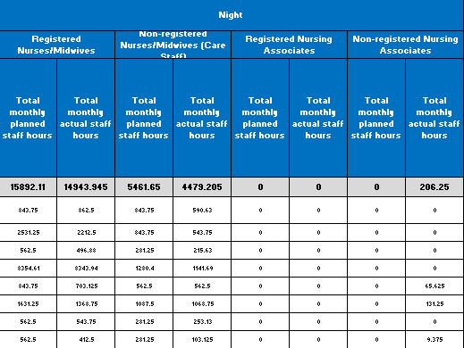
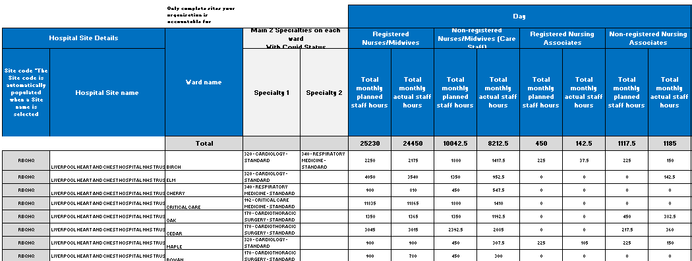

CHPPD for November
