

Board of Directors (Public)
Item

Board report

Subject: LHCH Monthly Staffing for Reporting Period for December 2020
Date of meeting 26th January 2021
Prepared by: Fiona Altintas, Divisional Head of Nursing & Quality for Surgery
Julie Roy, Divisional Head of Nursing & Quality for Medicine
Kirsty Dudley, Critical Care Manager,

Presented by: Sue Pemberton, Executive Director of Nursing & Quality
Purpose of Report for Noting

BAF Ref | WC1, WC2, WC3, WC4
Impact on BAF | None

1. Executive Summary

The National Quality Board (NQB) publication Supporting NHS providers to deliver the right staff, with the right skills, in the right place at the right time: Safe, sustainable and productive staffing (2016) outlines the expectations and framework within which decisions on safe and sustainable staffing should be made to support the delivery of safe, effective, caring, responsive and well-led care on a sustainable basis. It builds on National Institute for Health and Care Excellence (NICE) guidelines on safe staffing for nursing in adult inpatient wards, and is informed by NICE’s comprehensive evidence reviews of research, and subsequent evidence reviews focusing specifically on staffing levels and outcomes, flexible staffing and shift work. The need to consider the wider multidisciplinary team when looking at the size and composition of staff for any setting is highlighted as important within these documents.

The nursing establishment is defined as the number of registered nurses, registered nursing associates, assistant practitioners and healthcare assistants who work in a particular ward, department or team. Decision-making to ensure safe and sustainable staffing must follow a clear and logical process that takes account of the wider multidisciplinary team. Although registered nurses, registered nurse associates and healthcare assistants (HCAs) provide a significant proportion of direct care, other groups to consider include:

- Medical staff
- AHPs
- Pharmacists
- Advanced clinical practitioners
- Volunteers

The Model Hospital dashboard makes it possible to compare with peers using care hours per patient day (CHPPD). Finding peers that are close comparators is important as aspects such as patient acuity, dependency, turnover and ward support staff will differ. While NICE guidance identified evidence of “increased risk of harm associated with a registered nurse caring for more than 8 patients during the day shifts”, it clearly states that there is “no single nursing staff-to-patient ratio that can be applied across all acute adult inpatient wards”. NHSI state that they have found no new evidence to inform a change to this statement (NHS Improvement Evidence Review One 2016). This report details planned and actual nurse staffing levels for the month of December 2020, including any red flag concerns. All shifts were reported as safe during this month.

The POCCU 3 10 bedded area remains available for Covid positive patients and is staffed flexibly by the critical care team. This area has remained open caring for Covid positive ward level patients & critical care level patients during December. Due to an increased number of covid positive patients within the Trust, Maple Suite was converted to a red area for covid positive patients in December and Rowan Suite reverted to a surgical ward for pre-operative patients including urgent referrals. All CF patients continue to be safely cared for within Cherry ward (with its negative pressure rooms).

The Trust continues to carry a number of RN vacancies and during December, recruitment efforts have continued. A first virtual open event was held in early December, led by the senior nursing team along with education and HR colleagues and interviews that followed successfully recruited a number of nursing students. The temporary staffing team have continued efforts to recruit and have a number of HCAs in the recruitment process.

A pan-Mersey approach to overseas RN recruitment is being progressed with a number of registered nurses planned for April 2021.

During December, sickness and other absence including covid absence and absence due to covid contact through track and trace has significantly impacted ward and critical care staffing. Staffing escalation plans for during the covid pandemic have been reviewed, including critical care staffing, although have not needed to be implemented during December.

2. Exceptions

All planned staffing for nursing in LHCH is assessed as required for the ward to run at full capacity, if capacity is reduced then the planned staffing changes accordingly. In December 2020;

- There were no red flags on Cedar, Oak and Rowan wards. Cross divisional staff movement ensured that all shifts were reported as safe.
- There were no red flags on Birch, Cherry and Maple wards in December 2020.
- Maple ward has been affected by RN sickness during December and has received support (including ward manager support) from other clinical areas within the Medicine Division.
- Following the ward reconfigurations, Elm ward continues to have a significant number of RN vacancies. The divisional matron works closely with the Elm team to ensure appropriate levels of CCU trained staff are available for each shift. The CCU education lead continues to focus training for junior CCU staff. A number of staff have been recruited for the ward and a recruitment campaign is ongoing.
- One red flag was reported for Elm ward during December. A night shift was short of 2 RNs due to short notice sickness, 3 patients required 1:1 supervision and due to the acuity of the patients, this was a challenging shift. No patient safety incidents were reported and late shift staff stayed beyond their shift to support. This was escalated appropriately at the time and reported via datix.

3. Summary

This continues to be a challenging period of time for all staff who have adapted and worked flexibly through significant uncertainty. The Trust has experienced an increase in staff absence during the third wave of the covid pandemic which has contributed to increased staffing pressures, experienced across the NHS.
Each day a review of staffing takes place Trust wide to ensure that all patients can be cared for safely. This does, however, result in staff moves on occasion to manage risk and to provide additional support for areas where acuity of patients is higher. The ward manager weekend rota continues with a ward manager working each weekend to support the hospital co-ordinator in ensuring safe staffing across all areas and keeping in close contact with the duty on-call manager for the Trust.

4. Recommendations

The Board of Directors are requested to:
- Receive assurance related to nurse staffing for in-patient wards, as per national directives, noting actions being taken to ensure patient safety and quality of care are maintained.
- Receive assurance that staffing is appropriate and is flexed according to patient need and patient safety risk assessments, following escalation processes.
- Receive monthly reports of staffing at all planned board meetings.
- Receive the ‘care hours per patient day’ (CHPPD) data
- Receive assurance that the review of ward establishments and models of care for each inpatient area has been completed.
- Receive assurance that a robust recruitment plan continues, including the initial phase of an overseas recruitment plan.
- Receive assurance that revised models of nursing care, utilising Registered Nursing Associates and apprentices continue to be implemented.
- Receive assurance that alternative temporary staffing options are being explored.
- Receive assurance that staffing escalation plans are in place to be enacted when significant staffing pressures are seen during the covid pandemic.

Appendix 1
Introduction to Care Hours per patient Day (CHPPD)
One of the obstacles to eliminating unwarranted variation in nursing and care staff deployment across the NHS provider sector has been the absence of a single means of recording and reporting deployment. Conventional units of measurement that have been developed previously have informed the evidence base for staffing models ,– such as reporting staff complements using WTEs, skill-mix or patient to staff ratios at a point in time, but it is recognised by Nurse leaders may not reflect varying staff allocation across the day or include the wider multidisciplinary team. Also, because of the different ways of recording this data, no consistent way of interpreting productivity and efficiency is straightforward nor comparable between organisations.
To provide a single consistent way of recording and reporting deployment of staff working on inpatient wards/units we developed, tested and adopted Care Hours per Patient Day (CHPPD).
- CHPPD is calculated by adding the hours of registered nurses to the hours of healthcare support workers and dividing the total by every 24 hours of in-patient admissions (or approximating 24 patient hours by counts of patients at midnight)
- CHPPD reports split out registered nurses, registered & unregistered nurse associates and healthcare support workers to ensure skill mix and care needs are met. (The system calculates this automatically)
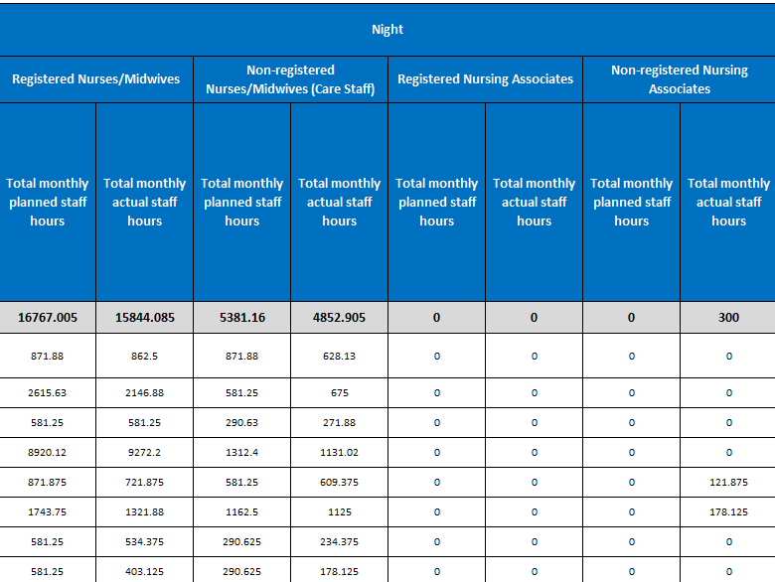
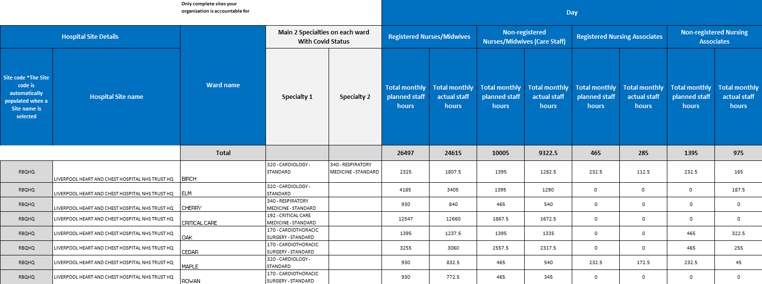

CHPPD for December
