

Board of Directors (Public)
Item

Board report

Subject: LHCH Monthly Staffing for Reporting Period for March 2018

Date of meeting ……

Prepared by: Fiona Altintas, Divisional Head of Nursing and Quality for Surgery
Steven Colfar, Divisional Head of Nursing & Quality for Clinical Services
Karen Wafer, Divisional Head of Nursing and Quality for Medicine
Presented by: Sue Pemberton, Executive Director of Nursing & Quality

1.0 Executive Summary

The National Quality Board (NQB) publication Supporting NHS providers to deliver the right staff, with the right skills, in the right place at the right time: Safe, sustainable and productive staffing (2016) outlines the expectations and framework within which decisions on safe and sustainable staffing should be made to support the delivery of safe, effective, caring, responsive and well-led care on a sustainable basis. It builds on National Institute for Health and Care Excellence (NICE) guidelines on safe staffing for nursing in adult inpatient wards, and is informed by NICE’s comprehensive evidence reviews of research, and subsequent evidence reviews focusing specifically on staffing levels and outcomes, flexible staffing and shift work. The need to consider the wider multidisciplinary team when looking at the size and composition of staff for any setting is highlighted as important within these documents.

The nursing establishment is defined as the number of registered nurses and healthcare assistants who work in a particular ward, department or team. Decision-making to ensure safe and sustainable staffing must follow a clear and logical process that takes account of the wider multidisciplinary team. Although registered nurses and healthcare assistants (HCAs) provide a significant proportion of direct care, other groups to consider include:

• Medical staff
• AHPs
• Pharmacists
• Advanced clinical practitioners
• Volunteers

The Model Hospital dashboard makes it possible to compare with peers using CHPPD and the Trust is awaiting this to be populated fully to allow for benchmarking. Finding peers that are close comparators is important as aspects such as patient acuity, dependency, turnover and ward support staff will differ While NICE guidance identified evidence of “increased risk of harm associated with a registered nurse caring for more than 8 patients during the day shifts”, it clearly stated there is “no single nursing staff-to-patient ratio that can be applied across all acute adult inpatient wards”. NHSI state that they have found no new evidence to inform a change to this statement (NHS Improvement Evidence Review One 2016).

2.0 March 2018

This report details planned and actual nurse staffing levels for the month of March 2018, including any red flag concerns. All shifts were reported as safe during the month. All planned staffing for nursing in LHCH is assessed as required for the ward to run at full capacity, if capacity is reduced then the planned staffing changes accordingly. In March 2018;

- There was 1 shift on Oak ward where there was one RN less than planned however this was mitigated by Assistant Practitioners and Advanced Nurse Practitioners covering.
- On Mulberry ward when it is at full capacity (12 beds) we would plan to have 2 RNS on each shift however the ward generally runs with no more than 8 patients so the surgical division plan to have one nurse on each shift.
- Cherry ward and Maple are the CF units and their staffing is provided across both wards therefore, 3 nurses on shift is sufficient to provide the care expected to all patients, as there are a maximum of 23 patients between both wards.
- Staff on CCU highlighted that two night shifts were busy with high acuity. However, on review the staffing was acceptable and safe for the acuity of patients on these two shifts.

3.0 Summary

All shifts have been reported as safe. Each day a review of staffing takes place Trust wide to ensure that all patients can be cared for safely. This does, however, result in staff moves on occasion to manage risk and to provide additional support for areas where acuity of patients is higher.

4.0 Recommendations

The Board of Directors are requested to:
- Receive assurance related to nurse staffing for in-patient wards, as per national directives, noting actions being taken to ensure patient safety and quality of care are maintained.
- Receive assurance that staffing is appropriate and is flexed according to patient need and patient safety risk assessments, following escalation processes.
- Receive monthly reports of staffing at all planned board meetings.
- Receive the Care hours per patient day (CHPPD) data

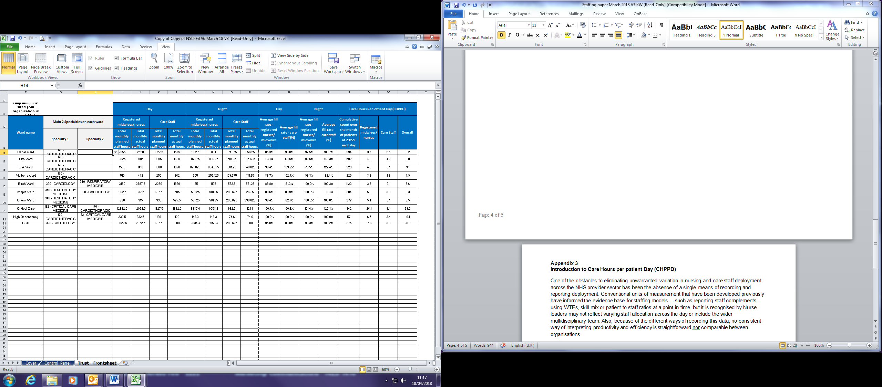
Appendix 3
Introduction to Care Hours per patient Day (CHPPD)
One of the obstacles to eliminating unwarranted variation in nursing and care staff deployment across the NHS provider sector has been the absence of a single means of recording and reporting deployment. Conventional units of measurement that have been developed previously have informed the evidence base for staffing models ,– such as reporting staff complements using WTEs, skill-mix or patient to staff ratios at a point in time, but it is recognised by Nurse leaders may not reflect varying staff allocation across the day or include the wider multidisciplinary team. Also, because of the different ways of recording this data, no consistent way of interpreting productivity and efficiency is straightforward nor comparable between organisations.
To provide a single consistent way of recording and reporting deployment of staff working on inpatient wards/units we developed, tested and adopted Care Hours per Patient Day (CHPPD).
- CHPPD is calculated by adding the hours of registered nurses to the hours of healthcare support workers and dividing the total by every 24 hours of in-patient admissions (or approximating 24 patient hours by counts of patients at midnight)
- CHPPD reports split out registered nurses and healthcare support workers to ensure skill mix and care needs are met. (The system calculates this automatically)

