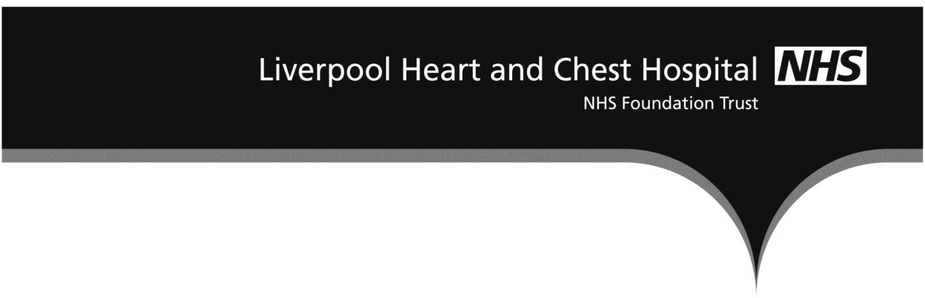

1. Clinical Services Exceptions - There was one red flag on HDU this month as one staff nurse and one HCA were allocated to care for two patients. Whilst this is not a breach in staffing levels, it is the Trust’s preference to have at least 2 nurses allocated regardless of patient numbers being at 2 or 4.
2. Medicine Division Exceptions - There were no red flags in medicine for November. All shifts reported as safe. Flexibility of the workforce was utilised as required across the division to support changes in acuity and staffing demand across the areas
3. Surgical Division Exceptions - On Mulberry ward, according to nice guidance, there would have been 5 red flags reported however as there were always less than 8 patients to one nurse this was deemed acceptable and patients were safe. On cedar ward Assistant Practitioners and Advanced Nurse Practitioners were utilised to ensure safe staffing levels. The reduction of RN was due to bank cancellation and sickness at short notice. All shifts were reported as safe. In July 2016, NHS Improvement requested that an additional methodology was used to collate data demonstrating care hours per patient day and this can be found within Table 1.
Table 1
Table 2 Nurse Staffing Return
The November 2017 data can be found below that is submitted to UNIFY and uploaded onto LHCH intranet /internet/NHS Choices based on the information included in this paper.
