Board of Directors (Public)
Item
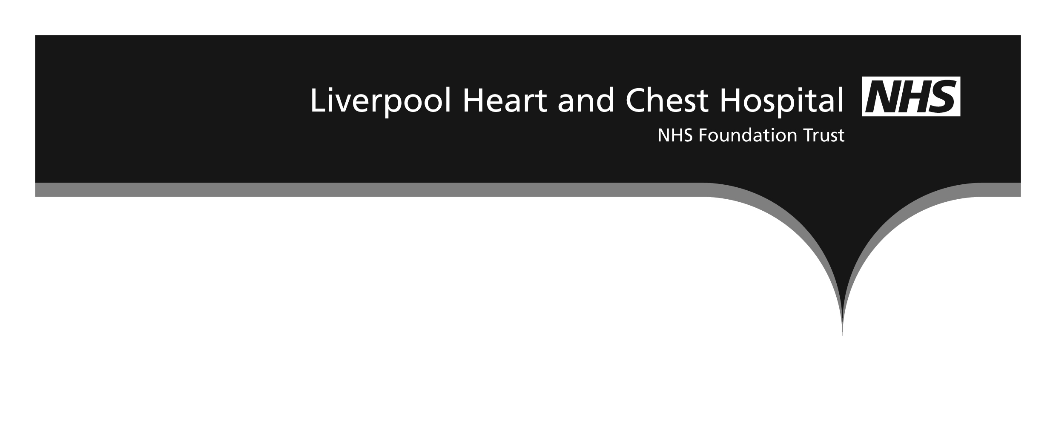

Board report

Subject: LHCH Monthly Staffing for Reporting Period for July 2017
Date of meeting 31st October 2017
Prepared by: Fiona Altintas, Divisional Head of Nursing and Quality for Surgery
Steven Colfar, Divisional Head of Nursing & Quality for Clinical Services
Karen Wafer, Divisional Head of Nursing and Quality for Medicine
Presented by: Sue Pemberton, Executive Director of Nursing & Quality

BAF Ref | Impact on BAF Risk Rating
1.1,1.2 | None

1.0 Executive Summary

This report details planned and actual nurse staffing levels for the month of July 2017, including any red flag concerns. All shifts were reported as safe during the month, however, there was1 red flag on Maple Suite, 4 red flags on Cherry ward, 2 red flags on Cedar (this was covered by increasing HCA staff) and 1 red flag on Mulberry all for having one registered nurse on duty however in all vases we were within the 1-8 patient ratio. There were 3 red flags on CCU. 2 x for a missed medication dose and 1 x for staffing (Explanation of red flags can be found in Appendix 1) In July 2016 NHS Improvement requested that an additional methodology was used to collate data demonstrating care hours per patient day and this can be found within the paper. There is no national directive for care hours per patient day. The Director of nursing has commenced some benchmarking work with Papworth and the Brompton hospitals to begin to compare data. Further information is explained further in Appendix 3.

2.0 Staffing Report
The July 2017 data can be found below that is submitted to UNIFY and uploaded onto LHCH intranet /internet/NHS Choices based on the information included in this paper.

July 2017 Data

Cherry Ward
Staff requirements on each shift: split into RN (Registered nurse), AP (Assistant Practitioner) and HCA (Healthcare Assistant)

 | Early shift | Late shift | Night shift
Monday - Friday | 2RN1AP 1HCA | 2RN 1AP 1HCA | 2RN 1HCA
Saturday /Sunday | 2RN 1HCA | 2RN 1HCA | 2RN 1HCA

 | Compliance with planned staffing % | Variance to planned staffing % | Comments/Actions
RN Day shifts | 91.1 | -8.9 | There were 4 red flags on cherry ward due to having 1 RN on shift. There were less than 8 patients on each occasion. Flexible working and support from Maple and CCU was in place. All shifts reported as safe.
RN Night shifts | 83.9 | -16.1
HCA / AP Day shifts | 55.6 | -44.4
HCA / AP Night shifts | 74.2 | -25.8

Birch Ward:
Staff requirements on each shift:
 | Early shift | Late shift | Night shift
Monday - Friday | 7RN 1AP 3HCA | 7RN 1AP 3HCA | 4RN 2HCA
Saturday /Sunday | 7RN 3HCA | 7RN 3HCA | 4RN 2HCA

 | Compliance with planned staffing % | Variance to planned staffing % | Comments/ Actions
RN Day shifts | 100.7 | +0.7 | No red flags on Birch ward. All shifts reported as safe. Variation of HCA support on night shifts due to enhanced levels of care. Flexibility across each side of Birch in place to support as required.
RN Night shifts | 99.2 | -0.8
HCA / AP Day shifts | 85.8 | -14.2
HCA / AP Night shifts | 101.6 | +1.6

Maple Suite:
Staff requirements on each shift:

 | Early shift | Late shift | Night shift
Monday - Friday | 2RN 1AP 1HCA | 2RN 1HCA | 2RN 1HCA
Saturday /Sunday | 2RN 1AP 1HCA | 2RN 1HCA | 2RN 1HCA

 | Compliance with planned staffing % | Variance to planned staffing % | Comments/Actions
RN Day shifts | 101.6 | +1.6 | Maple had 1 red flag due to have 1 x RN on a shift. CCU and Cherry ward supported as required. Maple suite provided support to other areas with higher acuity requiring HCA support. Acuity and occupancy is reviewed on a shift basis. All shifts are reported as safe.
RN Night shifts | 100 | 0
HCA / AP Day shifts | 62.9 | -37.1
HCA/ AP Night shifts | 100 | 0

Coronary Care Unit:
Staff requirements on each shift:

 | Early shift | Late shift | Night shift
Monday - Sunday | 7RN 1HCA | 7RN 1HCA | 7RN 1HCA

 | Compliance with planned staffing % | Variance to planned staffing % | Comments/Actions
RN Day shifts | 98.3 | -1.7 | 3 red flags on CCU due to 2 x missed medication doses that have been investigated. This was a delayed administration of anti rejection drugs due to a prescription error and delayed administration of IV frusemide due to human error. No harm came to the patients. 1 red flag was related to staffing reduction but acuity was low. All shifts reported as safe.
RN Night shifts | 94.9 | -5.1
HCA / AP Day shifts | 98.9 | -1.1
HCA / AP Night shifts | 90.3 | 9.7

Cedar Ward
Staff requirements on each shift:
Day | Early | Late | Night
Mon - Sunday | 6RN and 4HCA | 6RN and 3HCA | 4RN and 3HCA

 | Compliance with planned staffing % | Variance to planned staffing % | Comments/Actions
RN Day shifts | 91.9% | -8.1% | The gaps in RN are due to vacancies and staff awaiting start dates. All posts have been recruited to. The increase in HCA/AP shifts has been due to the use of assistant practitioners and HCAs at night to support patients with enhanced needs. There were 2 red flags for RN cover but HCA numbers increased to mitigate. All shifts are reported as safe.
RN Night shifts | 97.6% | -2.4%
HCA / AP Day shifts | 123% | +23%
HCA / AP Night shifts | 107.5% | +7.5

Elm Ward
Staff requirements on each shift:
 | Early shift | Late shift | Night shift
Monday - Sunday | 5 RN and 3 HCA | 4 RN and 3 HCA | 3 RN and 2 HCA

 | Compliance with planned staffing % | Variance to planned staffing % | Comments/Actions
RN Day shifts | 102.4% | +2.4% | Gaps in RN shifts are as a result of staff nurses awaiting start dates or PIN numbers hence an increase in HCAs. Band 4 AP were utilised to mitigate RN gaps on Night shifts, alongside increased HCA cover. All shifts are reported as safe.
RN Night shifts | 77.4% | -22.6%
HCA / AP Day shifts | 112.9% | +12.9%
CA / AP Night shifts | 127.4% | +27.4%

Oak Ward
Staff requirements on each shift:
 | Early shift | Late shift | Night shift
Monday - Sunday | 3 RN and 3 HCA | 3 RN and 3 HCA | 3 RN and 2 HCA

 | Compliance with planned staffing % | Variance to planned staffing % | Comments/Actions
RN Day shifts | 101.1% | +101% | The gaps in RN are due to vacancies and staff awaiting start dates or staff awaiting PIN numbers .Band 4 AP were utilised to mitigate RN gaps on Night shifts, alongside increased HCA cover. All shifts are reported as safe.
RN Night shifts | 63.7% | -36.3%
HCA / AP Day shifts | 111.3% | +11.3%
HCA / AP Night shifts | 135.5% | +135.5%

Mulberry Ward
Staff requirements on each shift:
 | Early shift | Late shift | Night shift
Monday - Thursday | 2 RN and 1 HCA | 2 RN and 1 HCA | 1 RN 1 AP / 2RN
Friday | 2 RN and 1 HCA | CLOSED | CLOSED
Saturday | CLOSED | CLOSED | CLOSED
Sunday | CLOSED | 2RN and 2 HCA | 1 RN 1 AP / 2RN

 | Compliance with planned staffing % | Variance to planned staffing % | Comments/Actions
RN Day shifts | 97.5% | -2.5% | The reduction in HCA shift cover on nights is where there were 2RNs on shift and occupancy did not require for HCAs to be present. 1 red flag was noted for July due to having 1 RN on shift but in those instances the number of patients was 4-7 patients at any one time. Mulberry ward was open for a total of 10 days in July. All HCA vacancies have been filled and awaiting start dates. All shifts have been reported as safe.
RN Night shifts | 90% | -10%
HCA / AP Day shifts | 105% | +5.0%
HCA / AP Night shifts | 80% | -20%
HDU
Staff requirements on each shift:

 | Early shift | Late shift | Night shift
Monday - Friday | 2RN +1 HCA | 2RN +1 HCA | 2RN +1HCA
Saturday - Sunday | 2RN + 1 HCA(sat)  Closed Sun | 2RN +1HCA (sat)  Closed Sun | Closed

 | Compliance with planned staffing % | Variance to planned staffing % | Comments/Actions
RN Day shifts | 100 | 0 | HDU utilisation continues at a low level as most activity can be accommodated within critical care. All shifts reported as safe.
RN Night shifts | 100 | 0
HCA / AP Day shifts | 100 | 0
HCA / AP Night shifts | 100 | 0

SICU
Staff requirements on each shift:
 | Compliance % | Variance % | Comments/Actions
RN Day shifts | 101.6 | +1.6 | HCA cover remains below plan but all shifts fully reported as safe due to lower than expected planned activity
RN Night shifts | 102.1 | +2.1
HCA / AP Day shifts | 100 | 0
HCA / AP Night shifts | 84.9 | -15.1

3.0 Summary

There was 1 red flag on Maple Suite, 4 red flags on Cherry ward, 2 red flag on Cedar Ward and 1 red flag on Mulberry due to not having 2 registered nurses on each shift. There were 3 red flags on CCU: 2 x for a missed medication dose and 1 x for staffing. The wards are noted to be safe and staffing is managed according to occupancy and reviewed on a daily basis by the Heads of Nursing and Ward Managers.

4.0 Recommendations

The Board of Directors are requested to:
- Receive assurance related to nurse staffing for in-patient wards, as per national directives, noting actions being taken to ensure patient safety and quality of care are maintained.
- Receive assurance that staffing is appropriate and is flexed according to patient need and patient safety risk assessments, following escalation processes.
- Receive monthly reports of staffing at all planned board meetings.
- Receive the Care hours per patient day (CHPPD) data

Appendix 1 Red Flags:
- Unplanned omission in providing patient medications.
- Delay of more than 30 minutes in providing pain relief.
- Patient vital signs not assessed or recorded as outlined in the care plan.
- Delay or omission of regular checks on patients to ensure that their fundamental care needs are met as outlined in the care plan. Carrying out these checks is often referred to as 'intentional rounding' and covers aspects of care such as:
  - Pain: asking patients to describe their level of pain level using the local pain assessment tool.
  - Personal needs: such as scheduling patient visits to the toilet or bathroom to avoid risk of falls and providing hydration.
  - Placement: making sure that the items a patient needs are within easy reach.
  - Positioning: making sure that the patient is comfortable and the risk of pressure ulcers is assessed and minimised.
- A shortfall of more than 8 hours or 25% (whichever is reached first) of registered nurse time available compared with the actual requirement for the shift. For example, if a shift requires 40 hours of registered nurse time, a red flag event would occur if less than 32 hours of registered nurse time is available for that shift. If a shift requires 15 hours of registered nurse time, a red flag event would occur if 11 hours or less of registered nurse time is available for that shift (which is the loss of more than 25% of the required registered nurse time).
- Less than 2 registered nurses present on a ward during any shift.

Appendix 2
July 2017

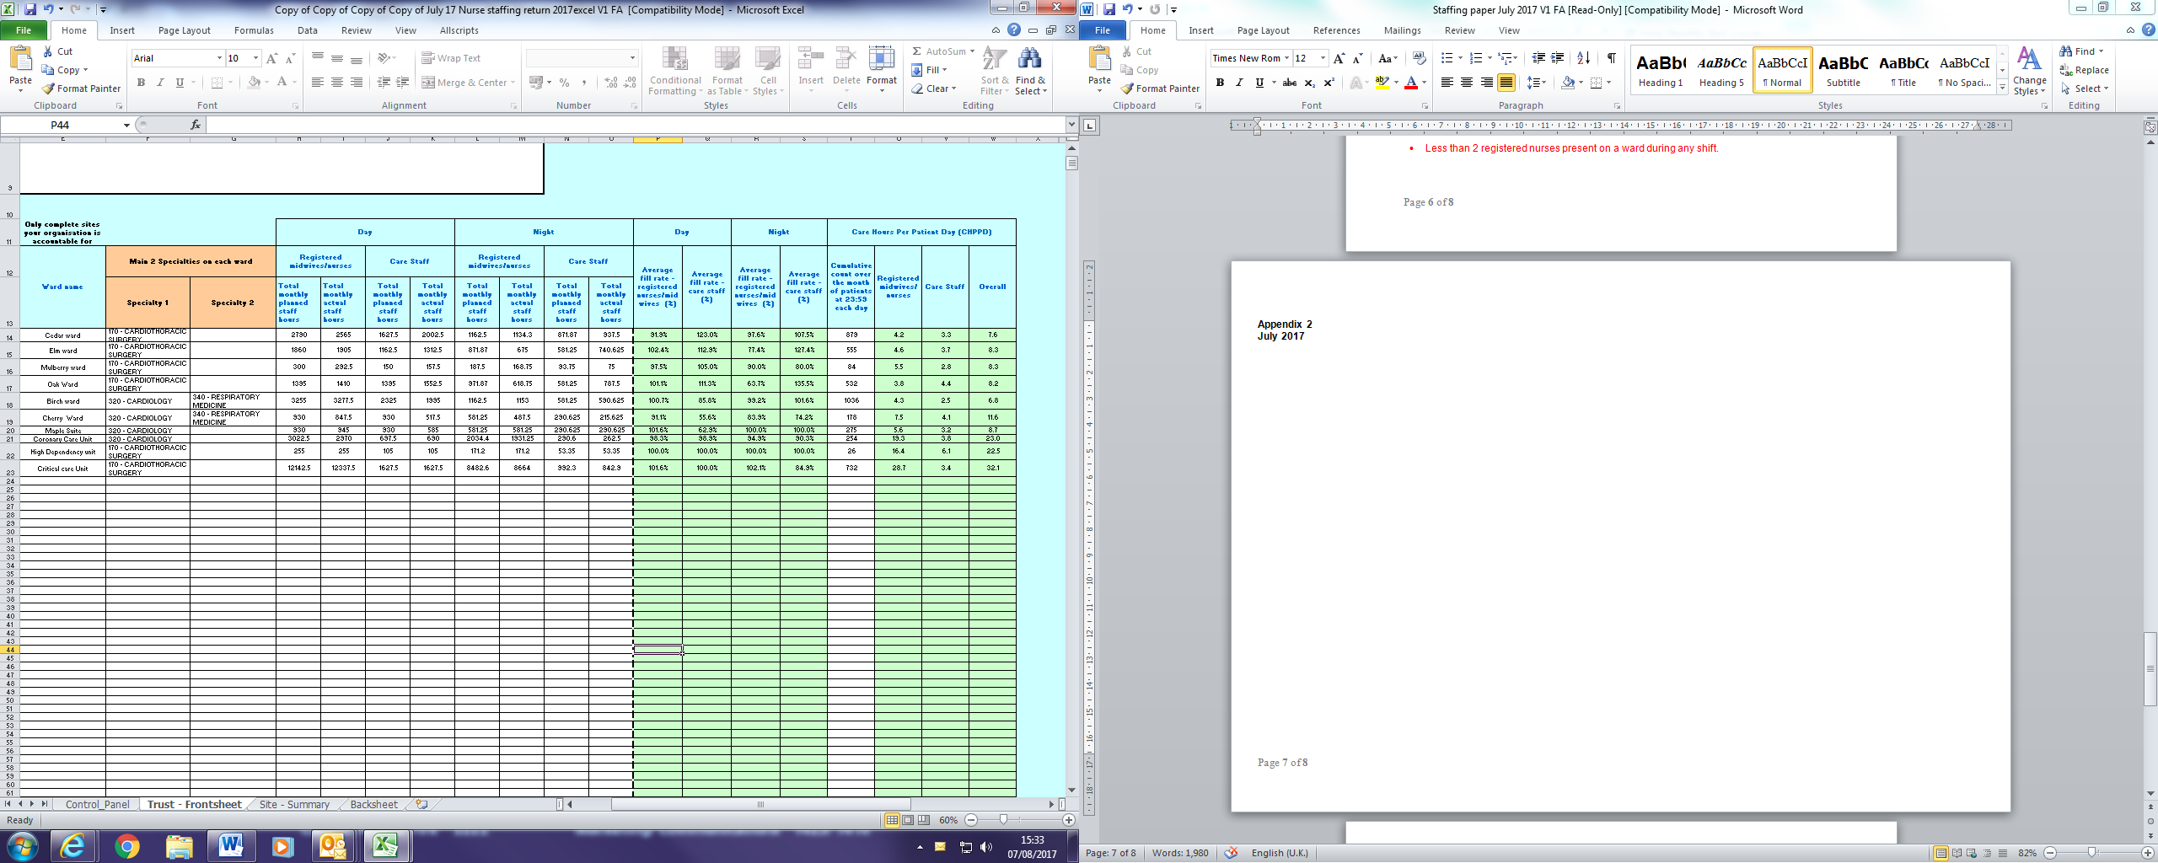

Appendix 3
Introduction to Care Hours per patient Day (CHPPD)
One of the obstacles to eliminating unwarranted variation in nursing and care staff deployment across the NHS provider sector has been the absence of a single means of recording and reporting deployment. Conventional units of measurement that have been developed previously have informed the evidence base for staffing models ,– such as reporting staff complements using WTEs, skill-mix or patient to staff ratios at a point in time, but it is recognised by Nurse leaders may not reflect varying staff allocation across the day or include the wider multidisciplinary team. Also, because of the different ways of recording this data, no consistent way of interpreting productivity and efficiency is straightforward nor comparable between organisations.
To provide a single consistent way of recording and reporting deployment of staff working on inpatient wards/units we developed, tested and adopted Care Hours per Patient Day (CHPPD).
- CHPPD is calculated by adding the hours of registered nurses to the hours of healthcare support workers and dividing the total by every 24 hours of in-patient admissions (or approximating 24 patient hours by counts of patients at midnight)
- CHPPD reports split out registered nurses and healthcare support workers to ensure skill mix and care needs are met. (The system calculates this automatically)

