Gender Pay Gap – March 2024
The following report provides Liverpool Heart and Chest ‘Gender Pay Gap’ report using data from ESR at the snapshot date 31/03/2024. Gender pay gap shows the difference in Mean (Average) and Median (Mid-point) pay between all men and women in the workforce. Gender pay gap is different from Equal pay as this deals with the pay differences between men and women who carry out the same jobs, similar jobs or work of equal value.
Data is based on 1889 eligible staff employed at LHCH at snapshot date of 31/03/2024 – 91.64% of staff in this sample are on Agenda for change terms and conditions, 0.95% Adhoc Payscales and 7.41% Medical Payscales. The highest proportion of staff within the Trust are ‘Registered Nursing’ staff who represent 33.25% of the Trust total. Grades have a set of paypoints for annual progression therefore the longer period of time that someone has been in a grade the higher their salary is likely to be irrespective of their gender.
Gender Profile:
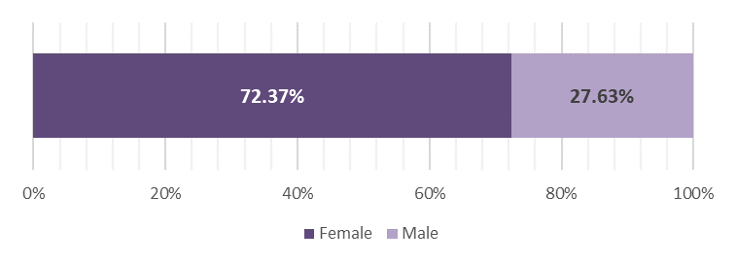
Gender Profile by Staff Group:
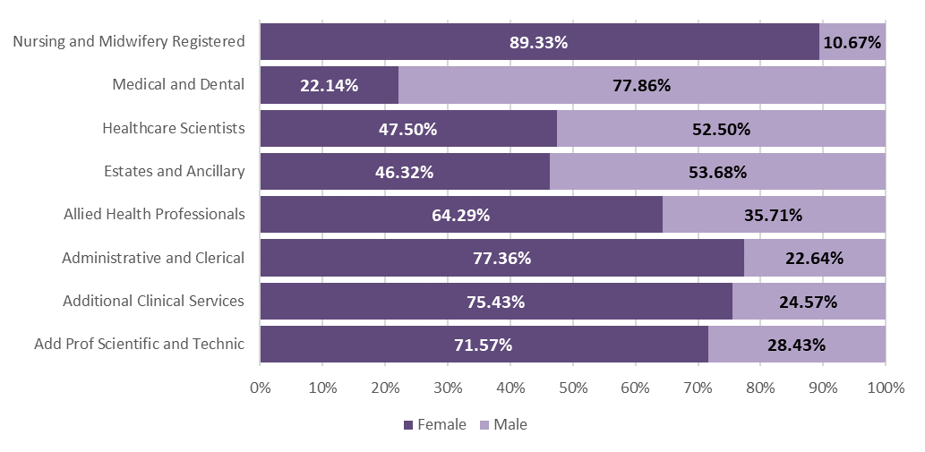
Females represent 89.33% of Nursing and Midwifery Registered staff with female representation in Additional Clinical Services, Add Prof Scientific & Technical and A&C above 70%. The remainder are between a 22.14% and 64.29% split. Medical and Dental is predominantly Male at 77.86% of staff.
Pay Gap – Ordinary Pay
Data is bases on snapshot of all fully paid staff in March 2024 or Week 52 2024 for weekly paid staff (Bank staff).
Women's Hourly Rate Gap is:
24.52% lower than men | 10.24% lower than men
which equates to £6.35 | which equates to £2.04
(Mean) | (Median)
Mean (or average) is based on hourly rate of ordinary pay including Basic Pay, Allowances and Shift Premium pay.
Median (or mid pay) is based on hourly rate of ordinary pay including Basic Pay, Allowances and Shift Premium pay.
Calculating using Mean can be affected by outliers (for example higher paid Consultants who receive Clinical Excellence Awards), so we would say that Median is a fairer representation for GPG. See example of variation of hourly pay by Mean/Median if we removed Consultants from the initial calculations.
Office for National Statistics* publication in 2024 estimates that the Gender Pay Gap is:
13.80% (Mean Gap) / 13.10% (Median)
*Source: Annual Survey of Hours and Earnings, Office for National Statistics (Provisional Data).
Source: Gender pay gap - Office for National Statistics (ons.gov.uk)
Zip file: genderpaygap2024provisional > File: PROV - Total Table 1.12 Gender pay gap 2024
Pay bands: The table below shows Pay Gap by Banding:
Men earn more than Woman in the following Bands |  |  | Women earn more than Men in the following Bands
Band | PayGap |  | Band | PayGap
Band 3 | 5.32% |  | Band 2 | 2.02%
Band 8a | 2.94% |  | Band 4 | 0.02%
Band 8c | 8.31% |  | Band 5 | 1.13%
Band 8d | 4.17% |  | Band 6 | 0.40%
Band 9 | 5.10% |  | Band 7 | 0.61%
Adhoc | 22.48% |  | Band 8b | 2.53%
 |  |  | Medical | 4.65%
Hourly Pay Quartiles:
An extract from ESR is used to rank male and female staff in order of hourly pay. These are split into 4 quarters based on hourly pay groupings (Quartile 1 is the lowest). The following graph shows the Gender split by Percentage’s and Headcount for each of the quartiles.
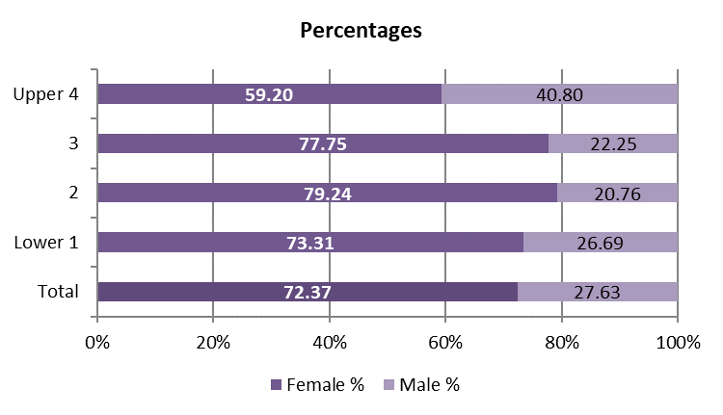
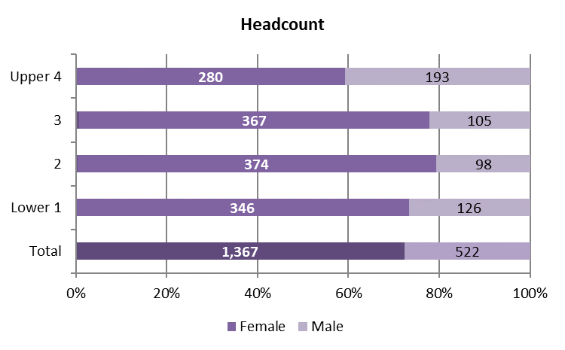

Quartile1: Admin and Clerical / Additional Clinical Services account for 77.54% of staff (up from 77.15 %) … of which 61.02% Female and 16.53% Male
Quartile2: Additional Clinical Services / Admin and Clerical / Reg Nursing account for 77.97% of staff (down from 80.33%) …. of which 66.74% Female and 11.23% Male
Quartile3: Reg Nursing account for 62.92% of staff (up from 58.82%) … of which 55.51% Female and 7.42% Male
Quartile4: Reg Nursing / Medical and Dental / Admin and Clerical account for 77.17% of staff (down from 77.71%) … of which 44.61% Female and 32.56% Male
Percentage of staff in each Quartile split by Gender:
Quartile | % of All Females in each Quartile | % of All Males in each Quartile
Lower 1 | 25.31 | 24.14
2 | 27.36 | 18.77
3 | 26.85 | 20.11
Upper 4 | 20.48 | 36.97
Total | 100.00 | 100.00

Ethnicity Split – Pay Gap
White
 | Female | Male | Difference | Pay Gap %
Average of Hourly Rate | 19.36 | 23.89 | 4.53 | 18.97%
BME
 | Female | Male | Difference | Pay Gap %
Average of Hourly Rate | 20.40 | 33.01 | 12.62 | 38.22%
Not Stated/Not Known
 | Female | Male | Difference | Pay Gap %
Average of Hourly Rate | 19.10 | 22.26 | 3.16 | 14.18%
ALL
 | Female | Male | Difference | Pay Gap %
Average of Hourly Rate | 19.54 | 25.89 | 6.35 | 24.52%

Disability Split – Pay Gap
Disabled
 | Female | Male | Difference | Pay Gap %
Average of Hourly Rate | 18.01 | 17.68 | -0.33 | -1.87%
Non-Disabled
 | Female | Male | Difference | Pay Gap %
Average of Hourly Rate | 19.94 | 26.42 | 6.48 | 24.53%
Unknown
 | Female | Male | Difference | Pay Gap %
Average of Hourly Rate | 18.70 | 25.40 | 6.70 | 26.36%
ALL
 | Female | Male | Difference | Pay Gap %
Average of Hourly Rate | 19.54 | 25.89 | 6.35 | 24.52%
Pay Gap – Bonus* Payments
*Only includes ‘Clinical Excellence Awards’ and ‘Discretionary Points’
Women's Bonus Pay Gap is:
43.59% lower than men | 37.84% lower than Men
(Mean) | (Median)
(Data based on 10 Females / 44 Males)
Who received Bonus Pay:
0.73% of Women | 8.43 % of Men
(Data based on 10 Females out of 1367 / 44 Males out of 522)
The Pay Gap is high between Male/Female staff due to the smaller range of bonuses* paid to the 10 female staff - ranging from £3k to £21.5k compared to the range paid to Male staff of £3k to £59.3k. This is reflected in the figures above.
If only including Consultant headcount as the Denominator the ‘Who received Bonus Pay’ % would be as below:
Who received Bonus Pay:
43.48% of Women | 56.41 % of Men
(Data based on 10 Females out of 23 / 44 Males out of 78)
Summary: -
Factors Contributing to Gaps shown in this report:
- High proportion of women in the workforce (72.37%)
- Nursing Registered accounting for 33.25% of total staff and within this data, of which 71.50% are Bands 5 & 6
- Males are a much higher proportion in Medical and Dental Consultant Posts (77.23%).

Over the coming months, we will be looking at the actions we can take to address the disparity between women and men who work for us.

